Handwritten English Numeral Recognition System
Submitted by –

Akshay Kumar Kushwaha | 20BCS6815
Prachi Agarwal | 20BCS6821
Sayak Das | 20BCS6830
Aniket Mittal | 20BCS6819

Bachelor of Engineering
In
Artificial Intelligence and Machine Learning

Under the Supervision of -
Prabhjot Singh Manocha



Chandigarh University, Gharuan, Mohali – 140413,
Punjab

Abstract - A dramatic change has occurred in machine learning with the development of Artificial Neural Network (ANN), making it more artificially intelligent in recent years. In addition to surveillance, health, medicine, sports, robotics, and drones, deep learning is used in many other fields as well due to its diverse range of applications. The Convolutional Neural Network (CNN), which blends Artificial Neural Networks (ANNs) and current deep learning strategies, is at the centre of phenomenal advances in deep learning. The technique has been applied to a wide range of tasks, including pattern recognition, sentence classification, speech recognition, face recognition, text categorization, document analysis, scene identification, and handwriting recognition. Using varying numbers of hidden layers and epochs, the authors investigate the variation in accuracy of CNN to classify handwritten numbers, and make comparisons between the different accuracy levels. This experiment was designed to evaluate the performance of CNN using the Modified National Institute of Standards and Technology (MNIST) dataset. A stochastic gradient descent algorithm and backpropagation is used to train the network.

Second Year BTech Students,
Under The Supervision Of Prabhjot Singh Manocha Sir
Chandigarh University, Gharuan, Mohali – 140413, Punjab

Recognition of Handwritten English Numeral using
Convolutional Nerral Network in Python with Tensorflow
and Comparison of Performance for Various Hdden
Layers

Abstract—A dramatic change has been occurred in machine learning with the development of Artificial Neural Network (ANN), making it more artificially intelligent in recent years. In addition to surveillance, health, medicine, sports, robotics, and drones, deep learning is used in many other fields as well due to its diverse range of applications. The Convolutional Neural Network (CNN), which blends Artificial Neural Networks (ANNs) and current deep learning strategies, is at the centre of phenomenal advances in deep learning. The technique has been applied to a wide range of tasks, including pattern recognition, sentence classification, speech recognition, face recognition, text categorization, document analysis, scene identification, and handwriting recognition. Using varying numbers of hidden layers and epochs, the authors investigate the variation in accuracy of CNN to classify handwritten numbers, and make comparisons between the different accuracy levels. This experiment was designed to evaluate the performance of CNN using the Modified National Institute of Standards and Technology (MNIST) dataset. A stochastic gradient descent algorithm and backpropagation is used to train the network.
Keywords—Handwritten digit recognition, Convolutional
Neural Network (CNN), Deep learning, MNIST dataset, Epochs,
Hidden Layers, Stochastic Gradient Descent, Backpropagation
Keywords—Handwritten digit recognition, Convolutional
Neural Network (CNN), Deep learning, MNIST dataset, Epochs,
Hidden Layers, Stochastic Gradient Descent, Backpropagation

Keywords—Handwritten numeral recognition, Convolutional Neural Network (CNN), Deep Learning, MNIST dataset, Hidden Layers, Backpropagation

Introduction
Deep learning has become increasingly applicable in a wide range of fields as time goes on. For the analysis of visual imagery, Convolutional Neural Networks (CNN) are used. Examples of objects that can be detected or recognized using Convolutional Neural Networks include object detection, face recognition, robotics, video analysis, segmentation, pattern recognition, natural language processing, spam detection, topic categorization, regression analysis, speech recognition, and image classification. Deep Convolutional Neural Networks (CNNs) are able to recognize handwritten digits with an accuracy that exceeds human capabilities. The architecture of the CNN is based on the biological model of mammalian visual systems. It is recognized that the cat's visual cortex is sensitive to a tiny portion of the visual field which is recognized as the receptive field. The discovery was made by D. H. Hubel et al. in 1062. Neocognitron is a model for pattern recognition derived from D. H. Hubel et al was the first computer vision. It was introduced by Fukushima in 1980. In 1998, the framework of CNNs is designed by LeCun et al. which had seven layers of convolutional neural networks. From pixel values of images, it was capable of classifying handwritten digits. Training the model was done using gradient descent with back propagation. Digits are input into the handwritten recognition model. System capable of recognising it. A simple artificial neural network (ANN) has an input layer, an output layer and some hidden layers between the input and output layer. An ANN and a CNN share a similar structure. Each layer's weighted sum of the neurons becomes the input for a machine learning layer. However, not all neurons will be connected to the same layer. An equal number of neurons are connected to the local receptive field in each layer. To train the network, a cost function is generated. A comparison is made between the output of the network and the desired output. Signals are propagated back to the receptive field to optimize the value of the cost function to maximize the performance of the network through minimizing the cost function. The goal of this article is to observe the influence of hidden layers of a CNN for handwritten digits. Using Tensorflow, a Python library for working with neural networks, a convolutional neural network algorithm has been applied to a modified NIST dataset. Using different combinations of hidden layers of Convolutional Neural Networks, this paper analyses the variation in outcome results. We train the network using stochastic gradients and backpropagation, and test it using forward algorithms.

Literature Review
An overview of CNN literature shows CNN plays a significant role in many sectors such as image processing. Many fields have been impacted by CNN. Researchers have taken an interest in handwritten digit recognition as a means of detecting and classifying faults in nanotechnologies, such as semiconductor production. There have been many papers and articles published about this subject in recent years. The most accurate Deep Learning algorithms are multilayer CNN's using Keras and Theano with Tensorflow, compared to other commonly used algorithms like SVM, KNN, and RFC. Due to the accuracy of the CNN, this technology is being used increasingly for image classification, video analysis, and data analysis. A large-scale neural network is a challenge to develop as it has a lot of parameters needed to perform well. Scientists are trying to understand human feelings through sentiment recognition by varying different parameters. This is done by using CNN for both natural language processing and sentiment recognition. Many researchers are attempting to improve CNN's accuracy. The researchers demonstrated that deep nets perform better when they used simple back-propagation as the training method. The lowest MNIST error rate is obtained by using their architecture compared to NORB and CIFAR10. To make handwriting recognition more accurate, researchers are working on this problem. Three-node networks trained and tested on the MNIST have a 1.19% error rate. Depending on the input image noise, deep CNNs can be adjusted. Their architecture results in the lowest error rate on MNIST compare to NORB and CIFAR10 In order to reduce handwriting recognition error rates as much as possible, researchers are working on the issue. Based on training and testing the 3-NN on MNIST, a 1.19 % error rate is achieved. Deep CNN can adjust the noise of input images. New applications of CNN are being developed daily, along with numerous types of research. The error rate for research is being minimized to the utmost extent possible. Data from MNIST and CIFAR have been used to estimate error rates.

METHODOLOGY
We implemented neural network with 4 different layers – conv2D, MaxPooling2D, Flatten and Dense with different parameters. Then features are divided by 255 to rescale them into a range of [0,1] to avoid overflow during computation. Data is split up into 60,000 training and 10,000 testing examples. Feedforward is performed with the training set for calculating the hypothesis and then backpropagation is done in order to reduce the error between the layers. The regularization parameter lambda is set to 0.1 to address the problem of overfitting.

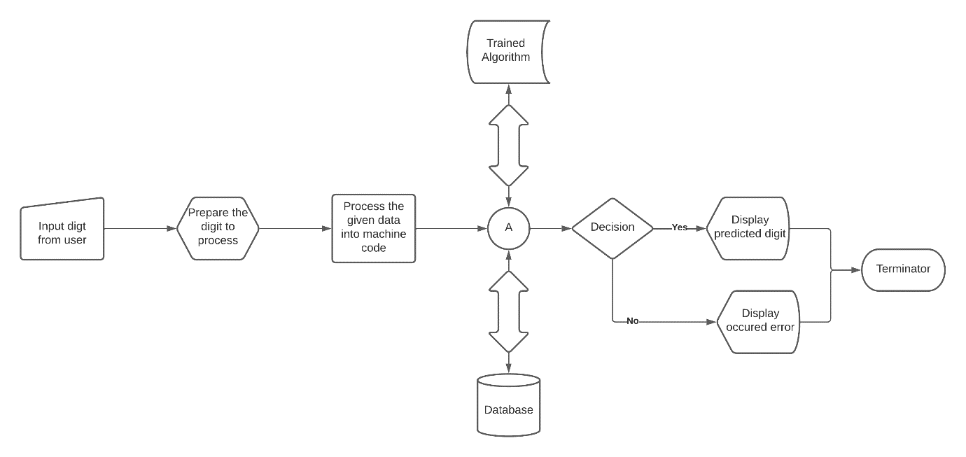

Fig 1. User view component UML diagram

This diagram shows the frontend view which user can see in details
- Start
- Input number (multiple digits)
- Program will start processing the data
- Input image will change into machine code (numeral digit also called binary pixels)
- It will come to the two-way process where the data will save to the local memory and along with that it will start processing the input data to the trained model
- After doing this part it will make decisions according to the response.
- If decision is yes then it will predict display the predicted result
- If decision is no then user will get an error message on their end
- After the execution the program will Terminate
- Stop

In STEP – 2: input can be in any format where user will able to write on the white board and along with that user will be able to insert the picture directly. It will help them to use these features in any format in any situation.
In STEP -5: the program is going to save only the last image searched by the user. Because if program save all the images then it will take a big space in local storage. We are only required only a single image to process and while searching another image the saved image will be replace by current image.
While performing decision, It will use saved model. Saved model will be on the local storage so that user should not have to download again and again. And It will take less time to predict the result on the input data.

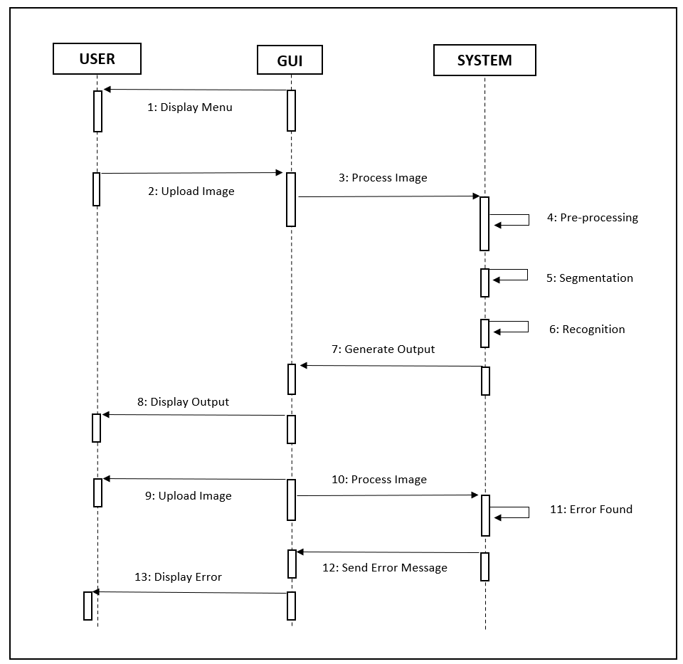

Fig 2. Middleware sequence UML diagram

This picture shows whole process used in this system.
- How user is connected with the GUI (middleware)
- How the GUI application is connected with the backed system
- How backend system is working in his own way

The detailed Description of this UML
- There is a GUI interface where user is going to connect with it. It can be using python program and using android application. This is the interface where user will able to get all the information about the result. There is an image box where user will able to select for the prediction. In application there is a display (result) box to print the output received from the backend. GUI is working like a middleware, which connects the user to the backend process.
- After selecting the image from the GUI user will pass the data to the backend where processing starts.
  - In backend, there is a trained model described into the methodology. In backed where is only going to be checking the result using the saved model by the very small code of python program.
  - In the backend, Program will recognize the input data. It will respond back the result to the middleware.
- The generated output will be displayed on the screen. Here user will able to see the result.
  - If there will be some error in the program it will print the wrong result.
  - If there will not be any numerical value then it will show error as user result.
- The program will be ready to execute, whenever user need this system. And help user to identify numbers correctly.

The steps in the figure 1 are as follows:
- Input a digit from the user, in this step the user provides the image of multiple digits by drawing on the screen.
- Prepare the image to process, in this we crop the image into separate single digits.
- Process the given data into machine code, storing the image in np array with dimensional vector of 28x28 in the form of 0’s and 1’s.
- Here MNIST dataset is used as a dataset for providing multiple images for training and testing purpose.
- Then the model is trained using various algorithms like feature extraction, Classification using CNN, in order to predict the accurate output.

MNIST DATASET
The Modified National Institute of Standards and Technology (MNIST) is a large set of computer vision data that is widely used to train and test various systems. It was generated from two special National Institute of Standards and Technology (NIST) data sets containing binary images of handwritten digits. The training sample contains handwritten numbers of 250 people, 50% of which are Census Bureau employees and the rest are high school students. However, it is often cited as the first dataset among other datasets to demonstrate the effectiveness of neural network.
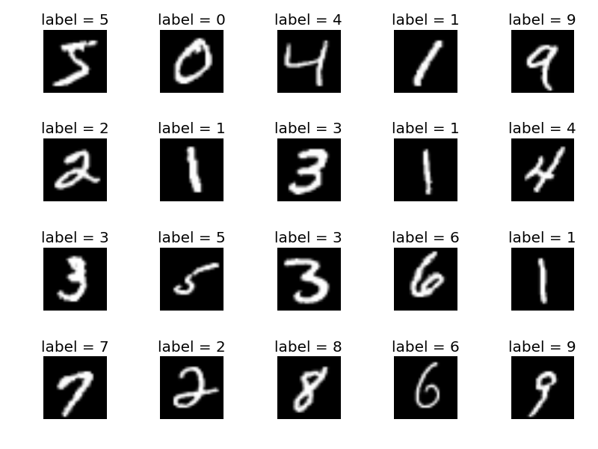
Fig 3. Sample images of MNIST handwritten digit dataset
The MNIST database consists of total 60,000 images which are used for training of the model. Some are used for cross validation process also. 10,000 images are used for testing purpose. The digits in images are centered in a fixed size image. All the digits in the dataset are greyscale and positioned in the image in fixed size so that the intensity must lies at the centre of the image and is of 28 x 28 pixels, so it forms an array with the dimensional vector of 28*28 = 784. The intensity of a pixel is represented by each vector component, which is a binary value.

IMPLEMENTATION
Implementation

1 Digit Recognition System –
In the very first, Started with the MNIST dataset. Divided the dataset as train and test and for recognition we are using labels for the same. In this process we are having (60000,28,28) train image size and (10000,28,28) test image size.
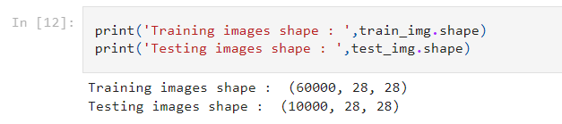
Range is 0 to 255 for each pixel value.
For this problem we are using Sequential model, an das layers we are using Flatten and Dense. In the model, there are one input layer followed by Flatten, two hidden layers followed by Dense(relu) and one output layer followed by Dense (SoftMax).
Now we have 4 types of layers followed by Flatten and Dense. Where flatten has 0 params, Dense has 401920 params, dense_1 has 262656 params and dense_2 has 5130 params. Total we 669706 params where all are Trainable and we got 0 non-trainable params.
Now compiling the sequential model, in that using Adam as optimizer and sparse categorical cross entropy as loss. And fitting the data into the model with epoch value 100 to get the high accuracy in this model. Saving the model into .h5 file. After evaluating model accuracy is 0.9831 with the test loss 0.4856.
For testing the result, we can send our own image after changing the pixel size to 28x28 and can predict the result.

2 Digit recognition system –
For two-digit recognition, we are creating our own dataset using MNIST dataset. There is a function ‘create dataset’ for multi label classification by horizontally stacking two images where the parameters for the dataset size is same size of MNIST dataset and which returns new dataset with two classes in one image and size of the returned dataset will not match with dataset size variable and concatenating both train and test dataset to create one large dataset. From the function we got the dataset shape (70000,28,28) after concatenating and removed 1986 examples from the same dataset.
Now the next step is to use multi hot encoding into target variable and devide the data into train, validation and test data. After splitting the dataset we have the training dataset of size (11528,28,56,1), validation dataset of size (3603,28,56,1) and testing dataset of size (2883,28,56,1) .
Now creating the generators for augmenting and reshaping the data for easy flow of data to the model. And moving towards the CNN model. For this also we are using sequential model imported from TensorFlow and Initializing the model flowed by Flatten using sigmoid function. In the result, there are 21 types of layers with different parameters. In these layers we got 320 params for conv2d layer, 9248 params for activation layer, 18496 params for cnv2d_2 layer, 36928 params for conv2d_3 layer, 73856 params for conv2d_4 layer, 147584 params for conv2d_5 layer, 295168 params for conv2d_6 layer, 590080 params for conv2d_7 layer, 98432 params for dense layer, 8256 params for dense_1 layer and 650 params for dense_2 layer. In this result we got zeros params for some layers those are activation, max_pooling2d, activation_1, max_pooling2d_1, activation_2, max_pooling2d_2, activation_3, max_pooling2d_3, activation_4, and flatten. Overall we have 1279018 params and all of them are trainable parameters.
After testing the model we have 0.0399 loss value with the accuracy of 0.759.
This is cause of mearging two values into a single pic is not very easy and while crosschecking it is unable to find the same set and label into the dataset. Which cause the low accuracy. It is taking a long time to get the result although we are using a large dataset. So, we can see that increasing the digit cause low accuracy.
So, We need to create a different model which should work like single digit but having multiple digits (number) at the same time. For that we can differenciate all the digits of a number and every time can check for a single digit which will be more accurate and able to get good accuracy which also help use to get good result in real life.
And here comes our numeral recognition system.
Numeral recognition system –
1st method –
For this model, firstly we are going to do the same. Using the inbuild functions transformed the dataset into train and test and resized it according to use. Using the train and test we can do some changes like this and can get the result same as given below in the image
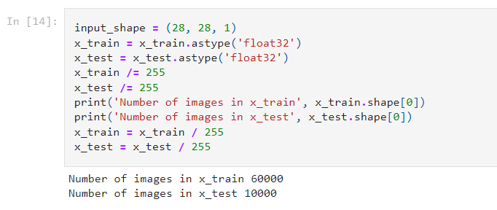
In this case, we are using sequential model with Conv2D, MaxPooling2D, Dense and Flatten types of layers with the kernel size (3,3), pool size (2,2) using relu and softmax activation. While compiling the model used adam optimizer with ‘sparse categorical crossentropy’ loss mothod. Fitting the model using high epoch value to get the batter accuracy. And saving the model in ‘.mode’ file.
Our model is ready to use where we can test the model. And by testing the model getting the result where accuracy is 0.9818 and loss is 0.0727. But there is a problem in this model. While testing with complex data not getting good result which is a sign of overfitting model. And that is why we can’t consider this model as good ones.
And this creates the need of another model with different selection of data using more layers.
2nd method –
In this model, we are going to use layers and models imported form keras followed by TensorFlow, MNIST imported from keras dataset and to_categorical imported from keras utils followed by TensorFlow.
In the next step split the model and fit into model. We proceed by fitting several simple neural network models using Keras (with TensorFlow as our backend) and collect their accuracy. For the competition, we are going to choose the model which performs the best on the validation set with the Neural Network layers.
Model 1: Simple Neural Network with 8 layers
In our first model, we will use the Keras library to train a neural network with the activation function set as relu. We shall rely on method SoftMax to determine output of the class followed by the activation function. The model reports the strength of the relationship between the model and the dependent variables.
In the summary we have 320params of conv2d_4 layer, 18496 params from conv2d_5 layer, 36928 params of maxpooling2d_3, 36928 params of dense_2 and 650 params of dense_3 layer. In this summary we have 0 params of maxpooling2d_2, maxpooling2d_3 and flatten_1 layers. Total we have 93322 params which are trainable.
In this case, we can see there are used 4 types of layers.
- conv2D
- MaxPooling2D
- Flatten
- Dense
in the output, we are getting a large parameter. where all the parameters are Trainable parameters.

Splitting into training and testing dataset
In the train_images taken the size of (60000, 28, 28, 1) and test_images of size (10000, 28, 28, 1).
Using to_categorical defining the two labels, one for train_lables and another for test_labels on this sequential model.
Next step is to compile the model, where using ‘rmsprop’ as optimizer ‘categorical_crossentropy’ as loss and to fit the train images with 5 epoches and having 64 batch size.
So, in the output we can see the model accuracy.
- in first Epoch getting the accuracy 0.9459
- in the second Epoch getting accuracy 0.9852
- in third Epoch getting accuracy 0.9898
- in 4th Epoch getting accuracy 0.9924
- in 5th Epoch getting accuracy 0.9940
And while checking the test set then we can get the accuracy that is 0.9881. it means our dataset can get most accurate result and but in some cases, it can predict wrong result.
Using `model.save` saving the model into mnist.h5 so that we'll able to use trained model any time without training it again and again.
GUI to use this model –
We are using ‘tkinter’ library which is used to create fast and easy GUI applications.
For the first, creating a window of size (480px X 640px ) height and width respectively. There are three function
One to clear the window
Another one to draw lines
And last one to activate the event to process image to get the result
While recognize the digit passing the taken image into function and getting the positions for different digits. Detecting the digits from images and creating a rectangle like a box using ‘cv2’ and predicting the real values for the same.

Result and Accuracy –
This is the highest score we got in the project which is for accuracy we got 0.9940 while training and 0.9881 while testing images in the same dataset. And performing on the same accuracy while inserting the new images into the program.
So, we can say this is one of the best models implemented in this project.

Results And Discussion
Outputs of different accuracy models

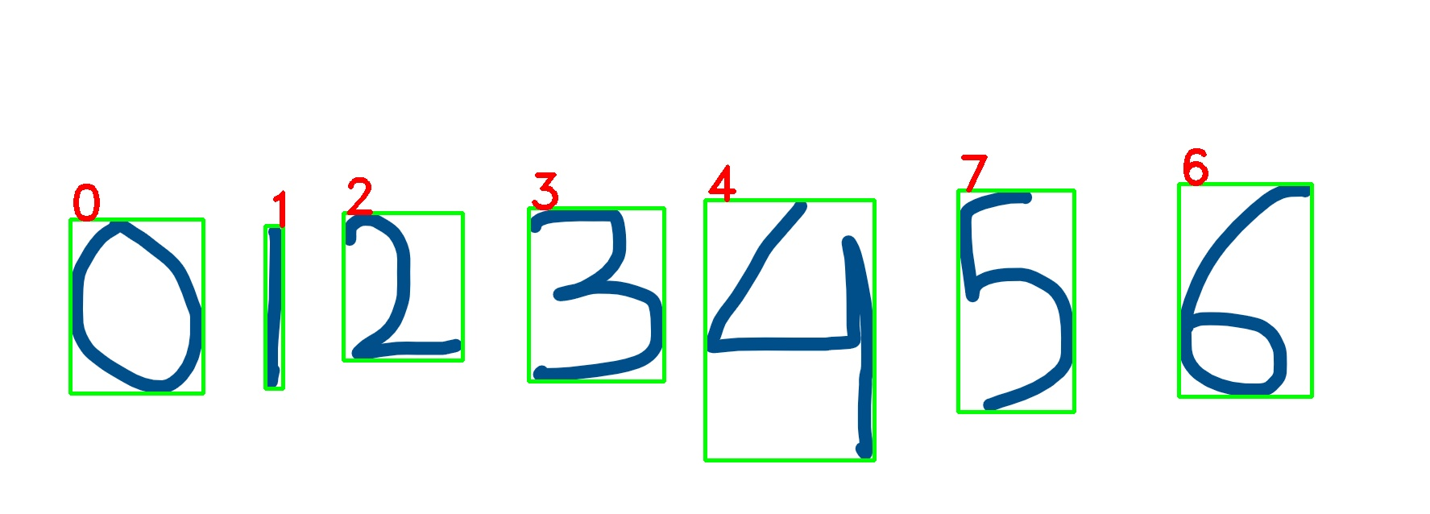

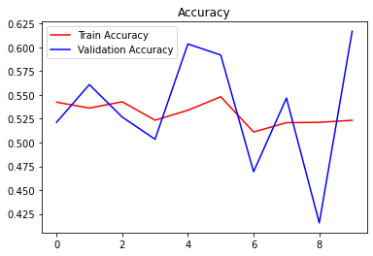

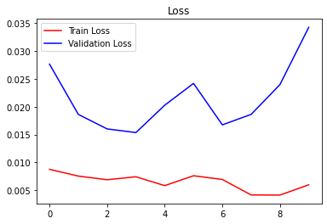

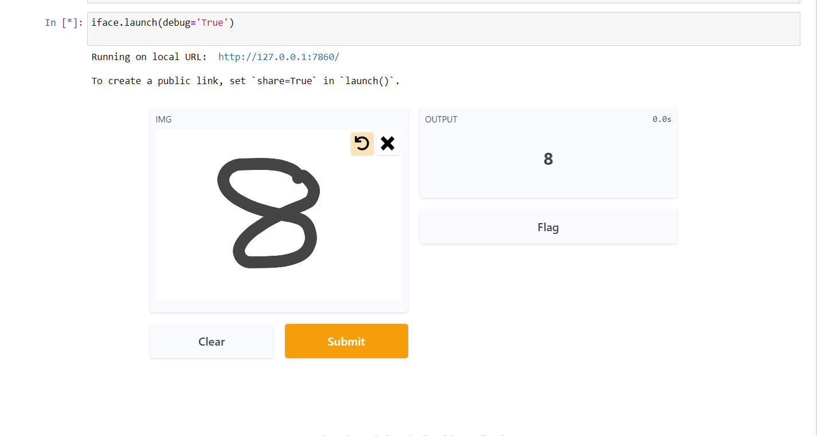

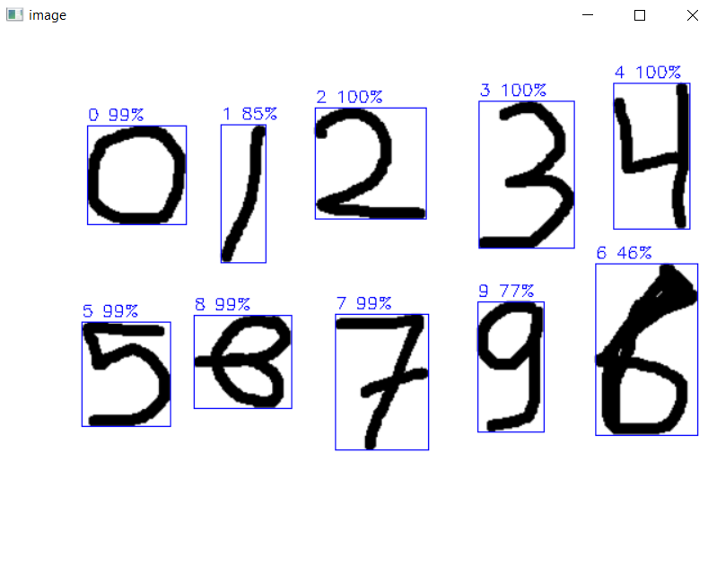

Comparison with Existing Research Work
There are several methods of digit recognition. The
handwritten digit recognition can be improved using some
widely held methods of the neural network like Deep Neural
Network (DNN), Deep Belief Network (DBF) and
Convolutional Neural Network (CNN), etc.
Tavanaei et al. proposed multi-layered unsupervised
learning in a spiking CNN model where they used MNIST
dataset to clear the blur images and found the overall
accuracy of 98% and the range of performance loss was
0.1% to 8.5% [20]. Rezoana et al. [28] proposed a seven-
layered Convolutional Neural Network for the purpose of
handwritten digit recognition where they used MNIST
dataset to evaluate the impact of the pattern of the hidden
layers of CNN over the performance of the overall network.
They have plotted the loss curves against the number of
epochs and found that the performance loss was below 0.1
for most of the cases and sometimes, in some cases, the loss
was less than 0.05. In another paper, Siddique et al. [29]
proposed an L-layered feed-forward neural network for the
handwritten digit recognition where they have applied neural
network with different layers on the MNIST dataset to
observe the variation of accuracies of ANN for different
combinations of hidden layers and epochs. Their maximum
accuracy in the performance was found 97.32% for 4 hidden
layers at 50 epochs.
Comparing with their above performances based on
MNIST dataset for the purpose of digit recognition we have
achieved better performance for the CNN. In our
experiment, we have found the maximum training accuracy
100% and maximum validation accuracy 99.92% both at
epoch 15. The overall performance of the network is found
99.21%. Moreover, the overall loss ranged from 0.026303 to
0.049449. Hence, this proposed method of CNN is more
efficient than the other existing method for digit recognition
There are several methods of digit recognition. The
handwritten digit recognition can be improved using some
widely held methods of the neural network like Deep Neural
Network (DNN), Deep Belief Network (DBF) and
Convolutional Neural Network (CNN), etc.
Tavanaei et al. proposed multi-layered unsupervised
learning in a spiking CNN model where they used MNIST
dataset to clear the blur images and found the overall
accuracy of 98% and the range of performance loss was
0.1% to 8.5% [20]. Rezoana et al. [28] proposed a seven-
layered Convolutional Neural Network for the purpose of
handwritten digit recognition where they used MNIST
dataset to evaluate the impact of the pattern of the hidden
layers of CNN over the performance of the overall network.
They have plotted the loss curves against the number of
epochs and found that the performance loss was below 0.1
for most of the cases and sometimes, in some cases, the loss
was less than 0.05. In another paper, Siddique et al. [29]
proposed an L-layered feed-forward neural network for the
handwritten digit recognition where they have applied neural
network with different layers on the MNIST dataset to
observe the variation of accuracies of ANN for different
combinations of hidden layers and epochs. Their maximum
accuracy in the performance was found 97.32% for 4 hidden
layers at 50 epochs.
Comparing with their above performances based on
MNIST dataset for the purpose of digit recognition we have
achieved better performance for the CNN. In our
experiment, we have found the maximum training accuracy
100% and maximum validation accuracy 99.92% both at
epoch 15. The overall performance of the network is found
99.21%. Moreover, the overall loss ranged from 0.026303 to
0.049449. Hence, this proposed method of CNN is more
efficient than the other existing method for digit recognition.
There are several methods of digit recognition. The
handwritten digit recognition can be improved using some
widely held methods of the neural network like Deep Neural
Network (DNN), Deep Belief Network (DBF) and
Convolutional Neural Network (CNN), etc.
Tavanaei et al. proposed multi-layered unsupervised
learning in a spiking CNN model where they used MNIST
dataset to clear the blur images and found the overall
accuracy of 98% and the range of performance loss was
0.1% to 8.5% [20]. Rezoana et al. [28] proposed a seven-
layered Convolutional Neural Network for the purpose of
handwritten digit recognition where they used MNIST
dataset to evaluate the impact of the pattern of the hidden
layers of CNN over the performance of the overall network.
They have plotted the loss curves against the number of
epochs and found that the performance loss was below 0.1
for most of the cases and sometimes, in some cases, the loss
was less than 0.05. In another paper, Siddique et al. [29]
proposed an L-layered feed-forward neural network for the
handwritten digit recognition where they have applied neural
network with different layers on the MNIST dataset to
observe the variation of accuracies of ANN for different
combinations of hidden layers and epochs. Their maximum
accuracy in the performance was found 97.32% for 4 hidden
layers at 50 epochs.
Comparing with their above performances based on
MNIST dataset for the purpose of digit recognition we have
achieved better performance for the CNN. In our
experiment, we have found the maximum training accuracy
100% and maximum validation accuracy 99.92% both at
epoch 15. The overall performance of the network is found
99.21%. Moreover, the overall loss ranged from 0.026303 to
0.049449. Hence, this proposed method of CNN is more
efficient than the other existing method for digit recognition.
There are several methods of digit recognition. The
handwritten digit recognition can be improved using some
widely held methods of the neural network like Deep Neural
Network (DNN), Deep Belief Network (DBF) and
Convolutional Neural Network (CNN), etc.
Tavanaei et al. proposed multi-layered unsupervised
learning in a spiking CNN model where they used MNIST
dataset to clear the blur images and found the overall
accuracy of 98% and the range of performance loss was
0.1% to 8.5% [20]. Rezoana et al. [28] proposed a seven-
layered Convolutional Neural Network for the purpose of
handwritten digit recognition where they used MNIST
dataset to evaluate the impact of the pattern of the hidden
layers of CNN over the performance of the overall network.
They have plotted the loss curves against the number of
epochs and found that the performance loss was below 0.1
for most of the cases and sometimes, in some cases, the loss
was less than 0.05. In another paper, Siddique et al. [29]
proposed an L-layered feed-forward neural network for the
handwritten digit recognition where they have applied neural
network with different layers on the MNIST dataset to
observe the variation of accuracies of ANN for different
combinations of hidden layers and epochs. Their maximum
accuracy in the performance was found 97.32% for 4 hidden
layers at 50 epochs.
Comparing with their above performances based on
MNIST dataset for the purpose of digit recognition we have
achieved better performance for the CNN. In our
experiment, we have found the maximum training accuracy
100% and maximum validation accuracy 99.92% both at
epoch 15. The overall performance of the network is found
99.21%. Moreover, the overall loss ranged from 0.026303 to
0.049449. Hence, this proposed method of CNN is more
efficient than the other existing method for digit recognition.
There are several methods of digit recognition. The
handwritten digit recognition can be improved using some
widely held methods of the neural network like Deep Neural
Network (DNN), Deep Belief Network (DBF) and
Convolutional Neural Network (CNN), etc.
Tavanaei et al. proposed multi-layered unsupervised
learning in a spiking CNN model where they used MNIST
dataset to clear the blur images and found the overall
accuracy of 98% and the range of performance loss was
0.1% to 8.5% [20]. Rezoana et al. [28] proposed a seven-
layered Convolutional Neural Network for the purpose of
handwritten digit recognition where they used MNIST
dataset to evaluate the impact of the pattern of the hidden
layers of CNN over the performance of the overall network.
They have plotted the loss curves against the number of
epochs and found that the performance loss was below 0.1
for most of the cases and sometimes, in some cases, the loss
was less than 0.05. In another paper, Siddique et al. [29]
proposed an L-layered feed-forward neural network for the
handwritten digit recognition where they have applied neural
network with different layers on the MNIST dataset to
observe the variation of accuracies of ANN for different
combinations of hidden layers and epochs. Their maximum
accuracy in the performance was found 97.32% for 4 hidden
layers at 50 epochs.
Comparing with their above performances based on
MNIST dataset for the purpose of digit recognition we have
achieved better performance for the CNN. In our
experiment, we have found the maximum training accuracy
100% and maximum validation accuracy 99.92% both at
epoch 15. The overall performance of the network is found
99.21%. Moreover, the overall loss ranged from 0.026303 to
0.049449. Hence, this proposed method of CNN is more
efficient than the other existing method for digit recognition.
There are several methods of digit recognition. The
handwritten digit recognition can be improved using some
widely held methods of the neural network like Deep Neural
Network (DNN), Deep Belief Network (DBF) and
Convolutional Neural Network (CNN), etc.
Tavanaei et al. proposed multi-layered unsupervised
learning in a spiking CNN model where they used MNIST
dataset to clear the blur images and found the overall
accuracy of 98% and the range of performance loss was
0.1% to 8.5% [20]. Rezoana et al. [28] proposed a seven-
layered Convolutional Neural Network for the purpose of
handwritten digit recognition where they used MNIST
dataset to evaluate the impact of the pattern of the hidden
layers of CNN over the performance of the overall network.
They have plotted the loss curves against the number of
epochs and found that the performance loss was below 0.1
for most of the cases and sometimes, in some cases, the loss
was less than 0.05. In another paper, Siddique et al. [29]
proposed an L-layered feed-forward neural network for the
handwritten digit recognition where they have applied neural
network with different layers on the MNIST dataset to
observe the variation of accuracies of ANN for different
combinations of hidden layers and epochs. Their maximum
accuracy in the performance was found 97.32% for 4 hidden
layers at 50 epochs.
Comparing with their above performances based on
MNIST dataset for the purpose of digit recognition we have
achieved better performance for the CNN. In our
experiment, we have found the maximum training accuracy
100% and maximum validation accuracy 99.92% both at
epoch 15. The overall performance of the network is found
99.21%. Moreover, the overall loss ranged from 0.026303 to
0.049449. Hence, this proposed method of CNN is more
efficient than the other existing method for digit recognition.
There are several methods of digit recognition. The
handwritten digit recognition can be improved using some
widely held methods of the neural network like Deep Neural
Network (DNN), Deep Belief Network (DBF) and
Convolutional Neural Network (CNN), etc.
Tavanaei et al. proposed multi-layered unsupervised
learning in a spiking CNN model where they used MNIST
dataset to clear the blur images and found the overall
accuracy of 98% and the range of performance loss was
0.1% to 8.5% [20]. Rezoana et al. [28] proposed a seven-
layered Convolutional Neural Network for the purpose of
handwritten digit recognition where they used MNIST
dataset to evaluate the impact of the pattern of the hidden
layers of CNN over the performance of the overall network.
They have plotted the loss curves against the number of
epochs and found that the performance loss was below 0.1
for most of the cases and sometimes, in some cases, the loss
was less than 0.05. In another paper, Siddique et al. [29]
proposed an L-layered feed-forward neural network for the
handwritten digit recognition where they have applied neural
network with different layers on the MNIST dataset to
observe the variation of accuracies of ANN for different
combinations of hidden layers and epochs. Their maximum
accuracy in the performance was found 97.32% for 4 hidden
layers at 50 epochs.
Comparing with their above performances based on
MNIST dataset for the purpose of digit recognition we have
achieved better performance for the CNN. In our
experiment, we have found the maximum training accuracy
100% and maximum validation accuracy 99.92% both at
epoch 15. The overall performance of the network is found
99.21%. Moreover, the overall loss ranged from 0.026303 to
0.049449. Hence, this proposed method of CNN is more
efficient than the other existing method for digit recognition.
There are several methods of digit recognition. The
handwritten digit recognition can be improved using some
widely held methods of the neural network like Deep Neural
Network (DNN), Deep Belief Network (DBF) and
Convolutional Neural Network (CNN), etc.
Tavanaei et al. proposed multi-layered unsupervised
learning in a spiking CNN model where they used MNIST
dataset to clear the blur images and found the overall
accuracy of 98% and the range of performance loss was
0.1% to 8.5% [20]. Rezoana et al. [28] proposed a seven-
layered Convolutional Neural Network for the purpose of
handwritten digit recognition where they used MNIST
dataset to evaluate the impact of the pattern of the hidden
layers of CNN over the performance of the overall network.
They have plotted the loss curves against the number of
epochs and found that the performance loss was below 0.1
for most of the cases and sometimes, in some cases, the loss
was less than 0.05. In another paper, Siddique et al. [29]
proposed an L-layered feed-forward neural network for the
handwritten digit recognition where they have applied neural
network with different layers on the MNIST dataset to
observe the variation of accuracies of ANN for different
combinations of hidden layers and epochs. Their maximum
accuracy in the performance was found 97.32% for 4 hidden
layers at 50 epochs.
Comparing with their above performances based on
MNIST dataset for the purpose of digit recognition we have
achieved better performance for the CNN. In our
experiment, we have found the maximum training accuracy
100% and maximum validation accuracy 99.92% both at
epoch 15. The overall performance of the network is found
99.21%. Moreover, the overall loss ranged from 0.026303 to
0.049449. Hence, this proposed method of CNN is more
efficient than the other existing method for digit recognition.
There are several methods of digit recognition. The
handwritten digit recognition can be improved using some
widely held methods of the neural network like Deep Neural
Network (DNN), Deep Belief Network (DBF) and
Convolutional Neural Network (CNN), etc.
Tavanaei et al. proposed multi-layered unsupervised
learning in a spiking CNN model where they used MNIST
dataset to clear the blur images and found the overall
accuracy of 98% and the range of performance loss was
0.1% to 8.5% [20]. Rezoana et al. [28] proposed a seven-
layered Convolutional Neural Network for the purpose of
handwritten digit recognition where they used MNIST
dataset to evaluate the impact of the pattern of the hidden
layers of CNN over the performance of the overall network.
They have plotted the loss curves against the number of
epochs and found that the performance loss was below 0.1
for most of the cases and sometimes, in some cases, the loss
was less than 0.05. In another paper, Siddique et al. [29]
proposed an L-layered feed-forward neural network for the
handwritten digit recognition where they have applied neural
network with different layers on the MNIST dataset to
observe the variation of accuracies of ANN for different
combinations of hidden layers and epochs. Their maximum
accuracy in the performance was found 97.32% for 4 hidden
layers at 50 epochs.
Comparing with their above performances based on
MNIST dataset for the purpose of digit recognition we have
achieved better performance for the CNN. In our
experiment, we have found the maximum training accuracy
100% and maximum validation accuracy 99.92% both at
epoch 15. The overall performance of the network is found
99.21%. Moreover, the overall loss ranged from 0.026303 to
0.049449. Hence, this proposed method of CNN is more
efficient than the other existing method for digit recognition.
There are several methods of digit recognition. The
handwritten digit recognition can be improved using some
widely held methods of the neural network like Deep Neural
Network (DNN), Deep Belief Network (DBF) and
Convolutional Neural Network (CNN), etc.
Tavanaei et al. proposed multi-layered unsupervised
learning in a spiking CNN model where they used MNIST
dataset to clear the blur images and found the overall
accuracy of 98% and the range of performance loss was
0.1% to 8.5% [20]. Rezoana et al. [28] proposed a seven-
layered Convolutional Neural Network for the purpose of
handwritten digit recognition where they used MNIST
dataset to evaluate the impact of the pattern of the hidden
layers of CNN over the performance of the overall network.
They have plotted the loss curves against the number of
epochs and found that the performance loss was below 0.1
for most of the cases and sometimes, in some cases, the loss
was less than 0.05. In another paper, Siddique et al. [29]
proposed an L-layered feed-forward neural network for the
handwritten digit recognition where they have applied neural
network with different layers on the MNIST dataset to
observe the variation of accuracies of ANN for different
combinations of hidden layers and epochs. Their maximum
accuracy in the performance was found 97.32% for 4 hidden
layers at 50 epochs.
Comparing with their above performances based on
MNIST dataset for the purpose of digit recognition we have
achieved better performance for the CNN. In our
experiment, we have found the maximum training accuracy
100% and maximum validation accuracy 99.92% both at
epoch 15. The overall performance of the network is found
99.21%. Moreover, the overall loss ranged from 0.026303 to
0.049449. Hence, this proposed method of CNN is more
efficient than the other existing method for digit recognition.
There are several methods of number recognition. The recognition of handwritten digits can be improved by using a number of widely used neural network methods such as Deep Neural Networks (DNNs), Deep Belief Networks (DBFs) and Neural Networks (CNN) etc. Tavanai et al. proposed unsupervised multi-layer learning in a modern CNN model, in which they used the MNIST dataset to remove the fuzzy images and found an overall accuracy of 98% and a wide range of performance reductions. yield from 0.1% to 8.5%. Rezoana et al. proposed a seven-layer agglomeration neural network for handwritten digit recognition purposes in which they used the MNIST dataset to evaluate the impact of CNN's hidden layer model on the performance of the entire network. They plotted the loss curves based on the number of epochs and found that the performance loss is less than 0.1 in most cases and sometimes in some cases the loss is less than 0.05 In another paper, Siddique et al. proposed a layered feedforward neural network for handwritten digit recognition in which they applied a neural network with different layers on the MNIST dataset to observe the variation of ANN accuracy. for different combinations of hidden layers and d periods. Their maximum performance accuracy is 97.32% for 4 hidden layers at 50 epochs. Comparing with their performance above based on MNIST dataset for digit recognition purpose, we got better performance for CNN. In our experiment, we have found the maximum training accuracy 100% and maximum validation accuracy 99.92% both at epoch 15. The overall performance of the network is found 99.21%. Moreover, the overall loss ranged from 0.026303 to 0.049449. Hence, this proposed method of CNN is more efficient than the other existing method for digit recognition.

Conclusion
In this example, we show how a model can detect handwritten digits. It can later be developed to recognize characters and real-time handwriting. The identification of handwritten digits is the initial step in the large field of Artificial Intelligence and Computer Vision. As demonstrated by the experiment results, CNN outperforms alternative classifiers. More convolution layers and hidden neurons can improve the accuracy of the output.

It has the potential to eliminate the need for typing entirely. Digit recognition is a good prototype issue for learning about neural networks, and it provides an ideal platform for developing more complex deep learning approaches. In the future, we hope to create a real-time handwritten digit recognition system.

Handwritten digit recognition has several uses in the medical, financial, student management, and taxes processes, among others. To detect the digit from the handwritten picture, many classifiers such as KNN, SVM, and CNN are utilised. According to the review, CNN outperforms the competition. This study discusses the stages of HDR using a CNN classifier. MNIST dataset consists of handwritten numbers 0-9 and is a typical dataset used to test classifier performance.

HDR is divided into three phases. The first step is preprocessing, which involves converting the dataset into binary form and applying image processing on it. The second stage is segmentation, in which the picture is divided into several parts. The third stage is feature extraction, which involves identifying picture characteristics.

The final stage is classification, which employs classifiers such as KNN, SVM, and CNN. The use of CNN classifier improves HDR results significantly, but it may be enhanced more in terms of complexity, execution time, and accuracy of results by combining classifiers or combining it with another method.

References
- Mnist dataset image – David Yang published in Fenwick 16 APR 2019 https://medium.com/fenwicks/tutorial-1-mnist-the-hello-world-of-deep-learning-abd252c47709

- UML Diagram Deshboard Creately is a brand of Cinergix Pty. Ltd. Australia & Sri Lanka. https://creately.com/lp/uml-diagram-tool/
- MNIST dataset From Kaggle https://www.kaggle.com/c/digit-recognizer
- Nurul Ilmi, Tjokorda Agung Budi W and Kurniawan Nur R, “Handwriting Digit Recognation using Local Binary Pattern Varience and K-Nearest Neighbor,” 2016 Fourth International Conference on Information and Communication Technologies (ICoICT).
- Formulae for the model CNN to evaluate the best result
In 2015, Michael A. Nielsen, "Neural Networks and Deep Learning", Determination Press, 2015
http://neuralnetworksanddeeplearning.com/chap1.html#:~:text=The%20idea%20is%20to%20take,rules%20for%20recognizing%20handwritten%20digits.

- For guidance using Geeks for geeks from multiple dsources. Examples are
https://www.geeksforgeeks.org/handwritten-digit-recognition-using-neural-network/
This article is contributed by: Utkarsh Shaw (https://auth.geeksforgeeks.org/user/utkarshshaw/profile )
Tania (https://auth.geeksforgeeks.org/user/taniachanana02/profile )
Rishab Mamgai (https://auth.geeksforgeeks.org/user/rishabmamgai/profile )
- Nimisha Jain, Kumar Rahul, Ipshita Khamaru. AnishKumar Jha, Anupam Ghosh (2017). “Hand Written Digit Recognition using Convolutional Neural Network (CNN)”, International Journal of Innovations & Advancement in Computer Science, IJIACS,ISSN 2347 – 8616,Volume 6, Issue 5.
- Dr.Kusumgupta2 ,"A Comprehensive Review On Handwritten Digit Recognition Using Various Neural Network Approaches", International Journal Of Enhanced Research In Management & Computer Applications, Vol. 5,No. 5, Pp. 22-25, 2016.
- Saeed AL-Mansoori, "Intelligent Handwritten Digit Recognition using Artificial Neural Network", Int. Journal of Engineering Research and Applications, vol. 5, no. 5, pp. 46-51, 2015.

